***Definite Integration***

The definite integral defined in a bounded interval is a finite number. In this section we are going to concentrate on the definite integral and its properties.

**Definite integral:** If is a continuous function defined in the interval  then the definite integral with respect to *x* is defined as,

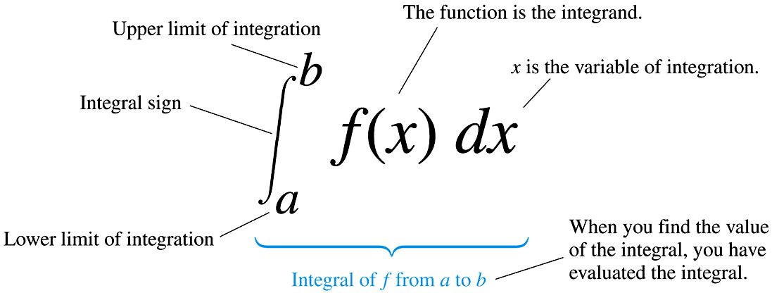

**Fundamental Theorem of Integral Calculus: If**  be a bounded and continuous function defined in the interval  where, *b* >*a* and there exists a function  such that , then



This is called the fundamental theorem of integral calculus.

**Integration as the limit of a sum:** Let,  be a bounded and continuous function defined in the interval  where *a*, *b* are finite quantities and .

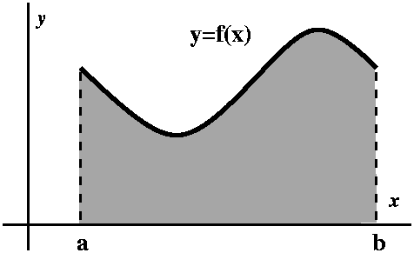

If the interval  be divided into *n* equal sub-intervals, each of length *h,* by the points  so that then the area enclosed by is defined as





which is also defined as the definite integral of  with respect to *x* between the limits *a* and *b* , and is denoted by the symbol,



where, *a* is called the lower limit and *b* is called the upper limit.

Therefore, 

***NOTE:***

1. 
2. 
3. 

**Problem-01:** Evaluate

**Solution:** Given that, 















**Problem-02:** Evaluate

**Solution:** Given that, 

















**Problem-03:** Evaluate

**Solution:** Given that, 

















**Problem-04:** Evaluate

**Solution:** Given that, 

















**Problem-05:** Evaluate

**Solution:** Given that, 



















**Problem-06:** Evaluate

**Solution:** Given that, 























**Problem-07:** Evaluate

**Solution:** Given that, 

















**Problem-08:** Evaluate

**Solution:** Given that, 

















***Some Definite integrations***

**Problem-01: Evaluate** 

**Solution: Let,** 















**Problem-02: Evaluate** 

**Solution: Let,** 













**Problem-03: Evaluate** 

**Solution: Let,** 











**Problem-04: Evaluate** 

**Solution: Let,** 













**Problem-05: Evaluate** 

**Solution: Let,** 

























**Problem-06: Evaluate** 

**Solution: Let,** 





















**Problem-07: Evaluate** 

**Solution: Let,** 







put,  

when  then 

when  then 

Now, 









**Problem-08: Evaluate** 

**Solution: Let,** 





put,  

when  then 

when  then 

Now, 











**Problem-09: Evaluate**  **Exercise-01:** 

**Solution: Let,**  **Ans:** 

 **Exercise-02:** 

 **Ans:** 





put,  

when  then 

when  then 

Now, 





















**Problem-10: Evaluate**  **Exercise-03:** 

**Solution: Let,**  **Ans:** 

 **Exercise-04:** 

 **Ans:** 





put,  

when  then 

when  then 

Now, 









**Problem-11: Evaluate** 

**Solution: Let,** 

put,  

when  then 

when  then 

Now, 

































**Problem-12: Evaluate** 

**Solution: Let,** 

Put  

when  then 

when  then 

Now 



Again let 



when  then 

when  then 















**General Properties of Definite Integrals:** The general properties are,

1. 
2. 
3. 
4. 
5. 
6. 

**Problem-01: Evaluate** 

**Solution: Let,** 







Now 











**Problem-02: Evaluate**   

**Solution: Let,** 





Now 











**Problem-03: Evaluate** 

**Solution: Let,** 





Now 























**Problem-04: Evaluate** 

**Solution: Let,** 





Now 





put 

when  then 

when  then 



















**Problem-05: Evaluate** 

**Solution: Let,** 





Now 





























**Problem-06: Evaluate** 

**Solution: Let,** 

put 

when  then 

when  then 















Now 











**Problem-07: Evaluate**  

**Solution: Let,** 





Now 











 … … … (1)

where, 

put 

when  then 

when  then 









From (1) we get







**Problem-08: Evaluate** 

**Solution: Let,** 





Now 











**Multiple choice questions:**

1. Which one of the following is answer of 

** **

** **

1. The value of the integral ****is :

** **

** **

1. Calculate 

** **

** **

1. Evaluate 

** **

** **

1. Find the indefinite integral 

** **

** **

1. What is the value of 

** **

** **

1. Evaluate the indefinite integral 

** **

** **

1. 

** **

** **

1. 

** **

** **

1. Evaluate the value of 

** **

** **